
Metro Parks Tacoma

Management & Budget Department - ATP Program
4702 South 19th Street
Tacoma WA, 98405
Phone (253) 305-1040

Fax (253) 305-1049

ATP

Weekly Payroll Report
(Instructions on back)

Prime / Sub-Contractor: |  |  |  |  |  | Union |  |  | Non-Union
Bid Number: |  |  |  |  | Contract Number:
Project Description:
Payroll Week Ending Date: |  |  |  |  | Payroll Number:

To the extent possible, Contractors shall recruit Apprentices from multiple trades or crafts. (ATP Regulations Section III)

Failure to submit this report attached to Weekly Certified Payrolls may result in Progress Payments being withheld.

- Total Labor hours worked by all employees this payroll period on this job:

- Total Wages paid including benefits to all employees this payroll period on this job:

The following employees have been identified as qualified ATP employees for the purpose of meeting the ATP Utilization Goal for this project (please use additional sheets if necessary).

3) Employee Name

4) Social Security 5) Craft
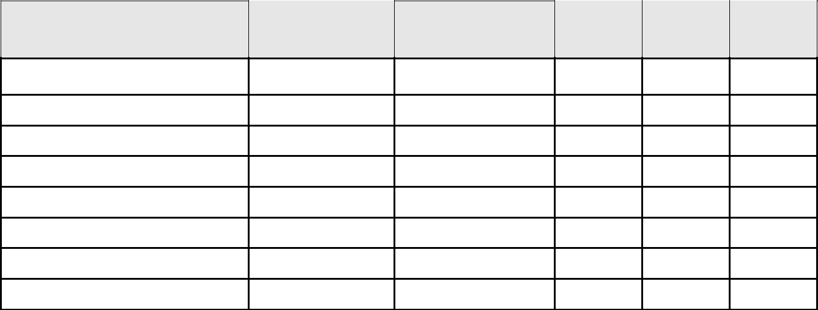

Number

- Type of hours

- Hours worked (this job)

- Rate of pay

$

$

$

$

$

$

$

$

I, the undersigned, do hereby certify under penalty of perjury, that the information contained herein is true and correct.

Signature of Responsible Officer Title Date

